**Berger Hut**

WEBSITE FOR EXPERIENCING TASTE

**A PROJECT REPORT**

***Submitted by***

**ARUNAV KUMAR**

***Submitted to Assistant Professor***

**GAURI THAKUR**

***in partial fulfillment for the award of the degree of***

**BACHELOR OF TECHNOLOGY**

**IN**

**COMPUTER SCIENCE AND ENGINEERING**



**Lovely Professional University, Punjab**

**12415508**

**OCTOBER 2024**

**BONAFIDE CERTIFICATE**

Certified that this project report **BERGER HUT** is the bonafide work of **ARUNAV KUMAR** who carried out the project work under my supervision.

**SIGNATURE**

**SUPERVISOR**

**SIGNATURE**

**CLASS MENTOR**

**SIGNATURE**

**HEAD OF THE DEPARTMENT**

**TABLE OF CONTENTS**

|  |  |  |
| --- | --- | --- |
| **CHAPTER NO.** | **PARTICULARS** | **PAGE NO.** |
| 1 | Introduction | 4 |
| 2 | Technologies used | 4 |
| 3 | Working of project | 5 |
| 4 | Snippets of written code | 6 |
| 5 | Screenshots of webpage | 9 |
| 6 | References | 12 |

**GitHub Project Link:**

***https://github.com/ARUNAV1591/Burger-Hut***

**INTRODUCTION**

Burger Hut is a responsive and visually appealing website for a fictional burger-selling company, designed and developed by a CSE student. The project aims to showcase the brand and products of "Burger Hut," highlighting the company’s variety of delicious burgers, menu options and etc. Built using HTML and CSS, the website serves as a dynamic portfolio for students learning web development, showcasing how to structure content, style elements, and responsive design principles. This project is an excellent foundation for understanding the core skills of frontend development, focusing on creating an engaging user experience while adhering to modern web design practices.

**TECHNOLOGIES USED**

**1. HTML (Hyper Text Markup Language)**

• Role: HTML is the foundation of any web application. It is used to create the structure and layout of web pages by defining elements such as headings, paragraphs, forms, buttons, and links.

• On the introductory page, HTML is used to build the shop info .

• On the Main page, HTML creates the divisions that contain products of various brands and items of respective category

**2. CSS (Cascading Style Sheets)**

• Role: CSS is used to style and visually enhance the HTML elements, improving the design and layout of the web pages. It allows you to define colors, fonts, spacing, animation and responsive layouts.

• CSS will be applied to the Intro page and the Home web page to create a visually appealing interface. This includes styling the buttons, background, and ensuring the web pages are responsive for various devices.

**WORKING OF PROJECT**

1. **Homepage:**
   * The homepage is designed to welcome visitors to Burger Hut.
   * It features a hero section with a catchy tagline, an image of a signature burger, and a call-to-action button to view the menu.
   * An introductory paragraph briefly describes Burger Hut’s commitment to quality ingredients and taste.
2. **Menu Page:**
   * A detailed menu page lists various burgers, including options for vegetarians, non-vegetarians, and specialties.
   * Each item includes a brief description, an image, and a price.
   * A “Special Deals” section highlights discounted offers or seasonal burgers, encouraging customers to try something new.
3. **About Us Page:**
   * This section shares Burger Hut’s story, values, and mission.
   * It includes information about the company’s dedication to quality ingredients and customer satisfaction.
   * A team section introduces key members, giving a personal touch to the brand.
4. **Contact Us Page:**
   * This page provides essential contact details, including an address, phone number, and email.
   * A simple HTML form allows users to submit inquiries or feedback directly through the website.
5. **Footer Section:**
   * A footer section on every page includes links to social media profiles, and links to essential pages like the privacy policy and terms of service.

**SNIPPETS OF WRITTEN CODE**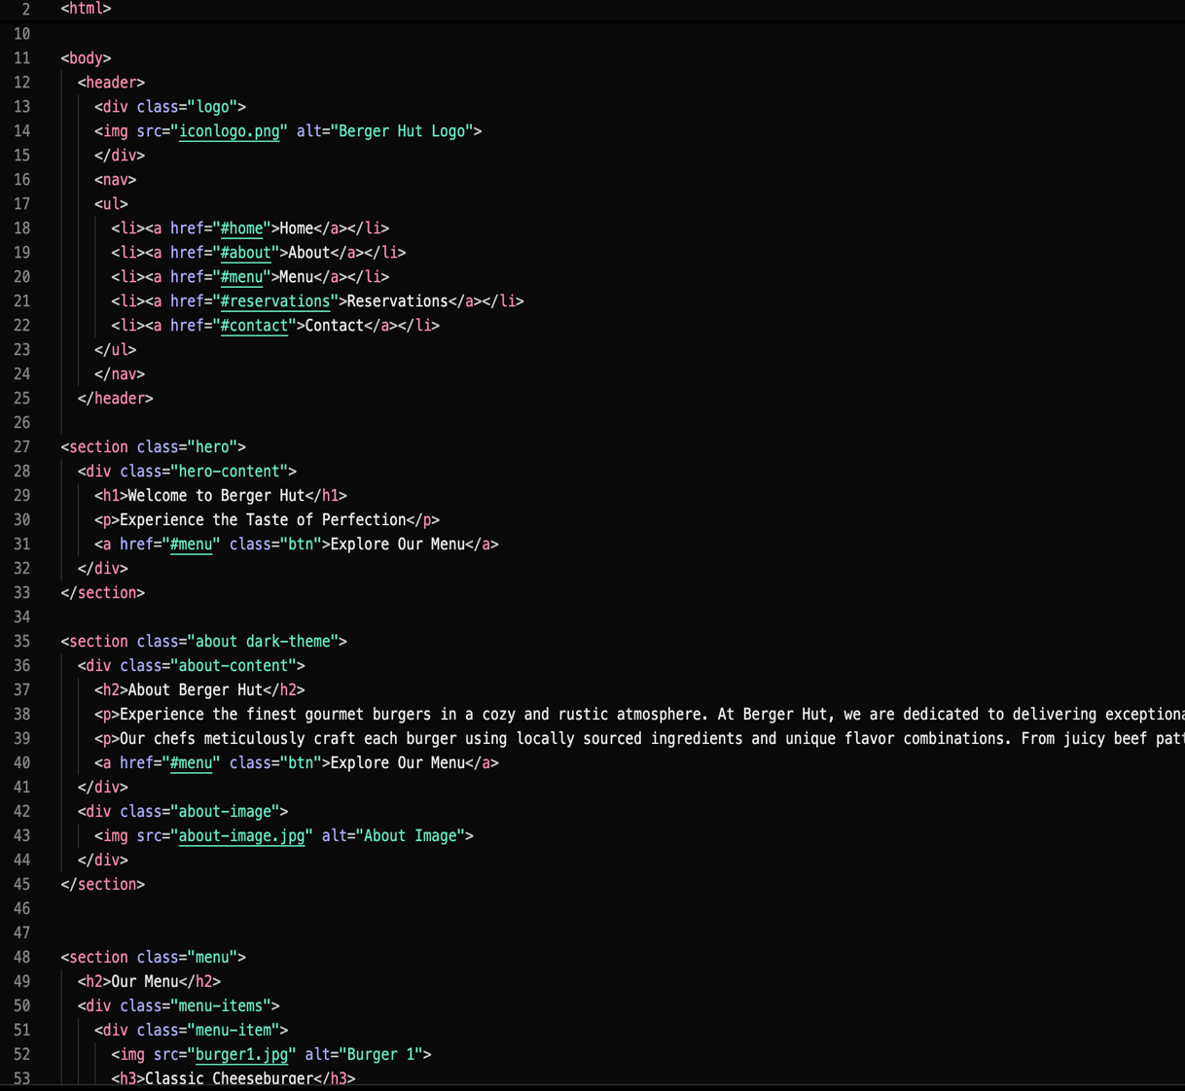

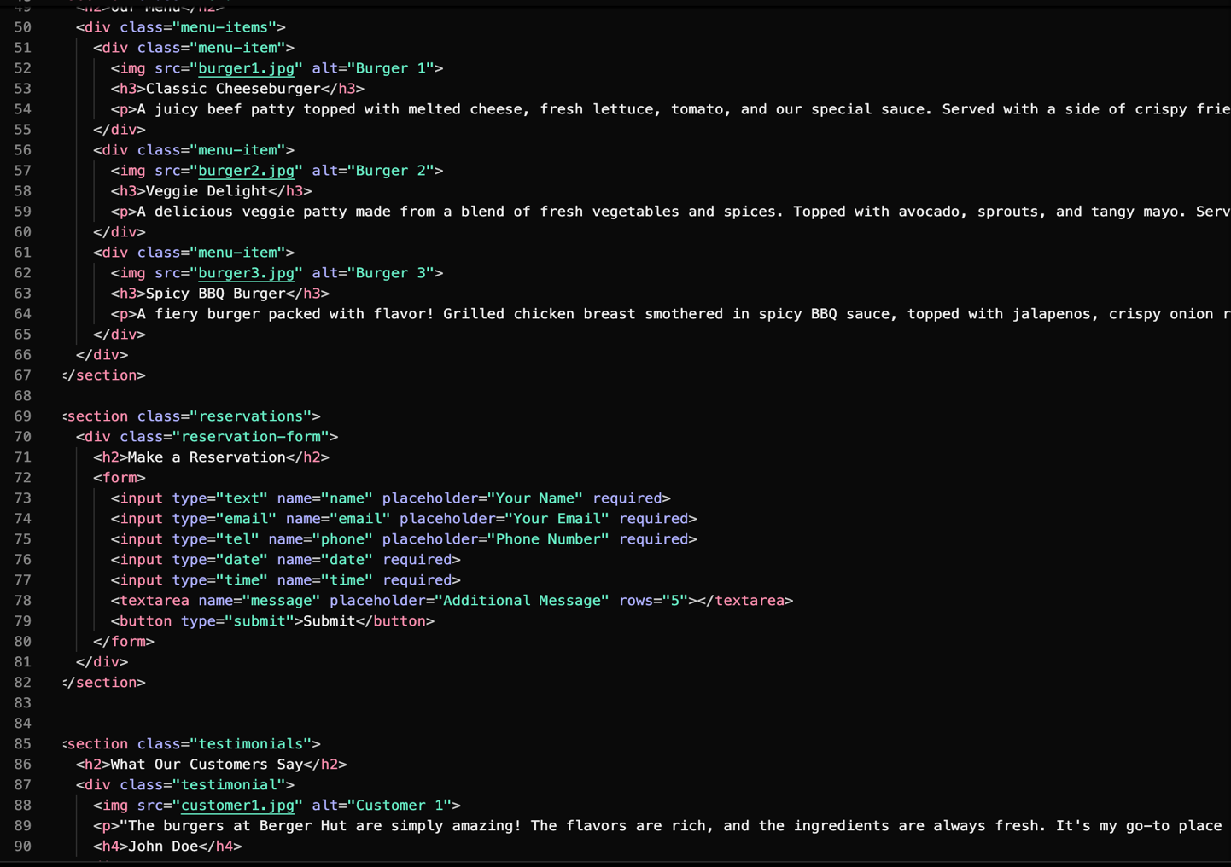

**SCREENSHOTS OF WEBPAGE**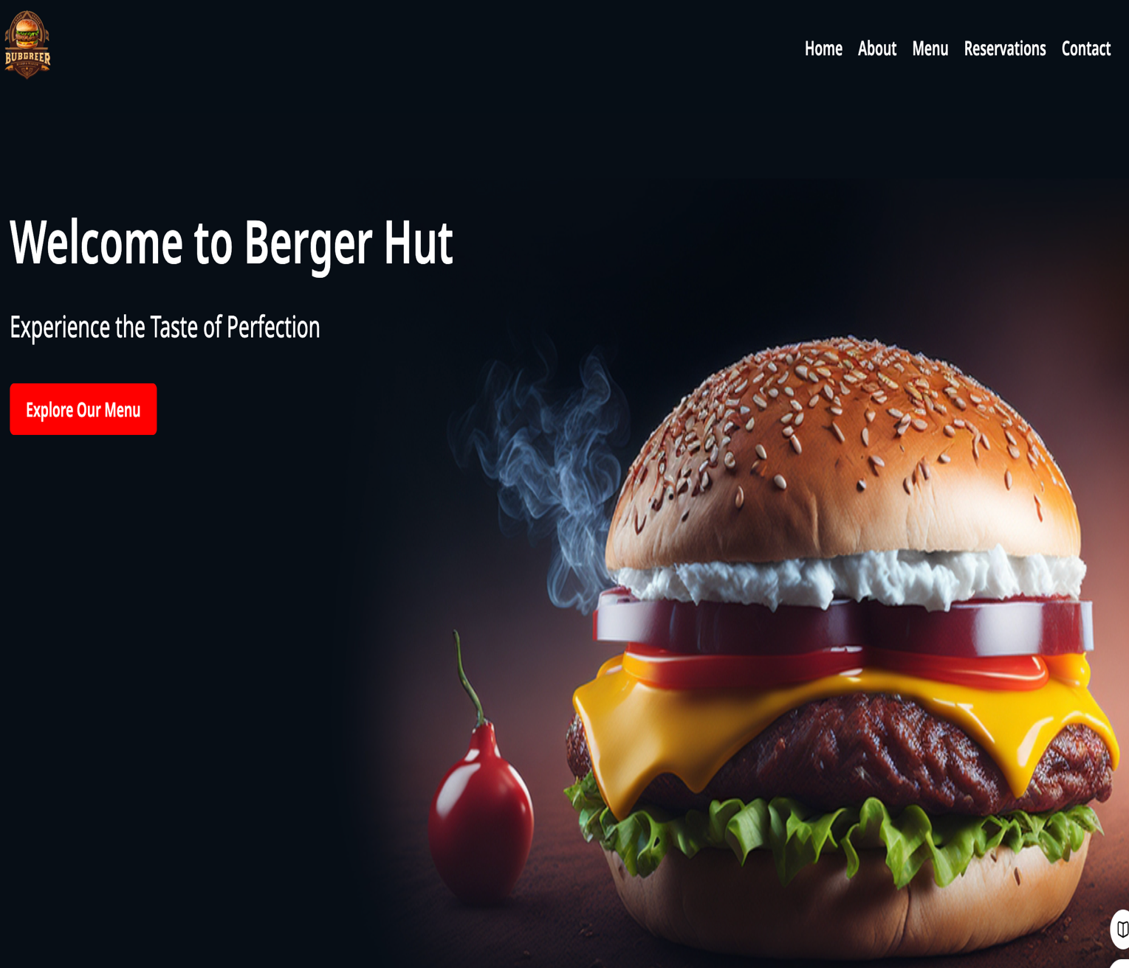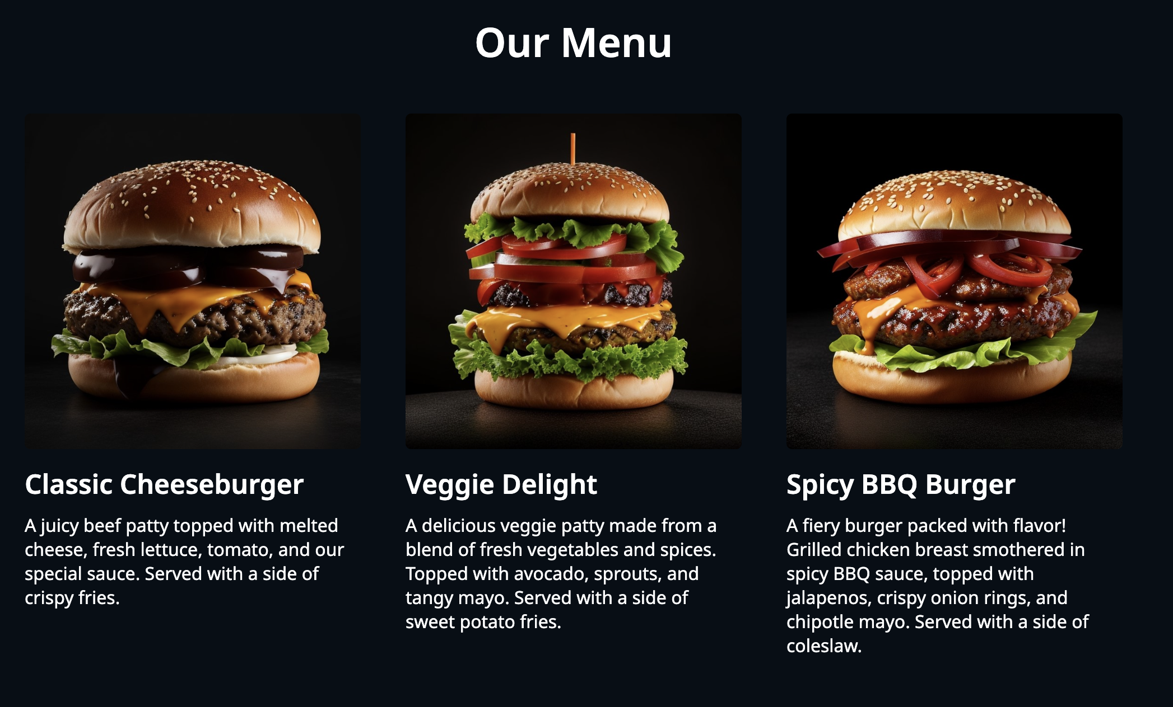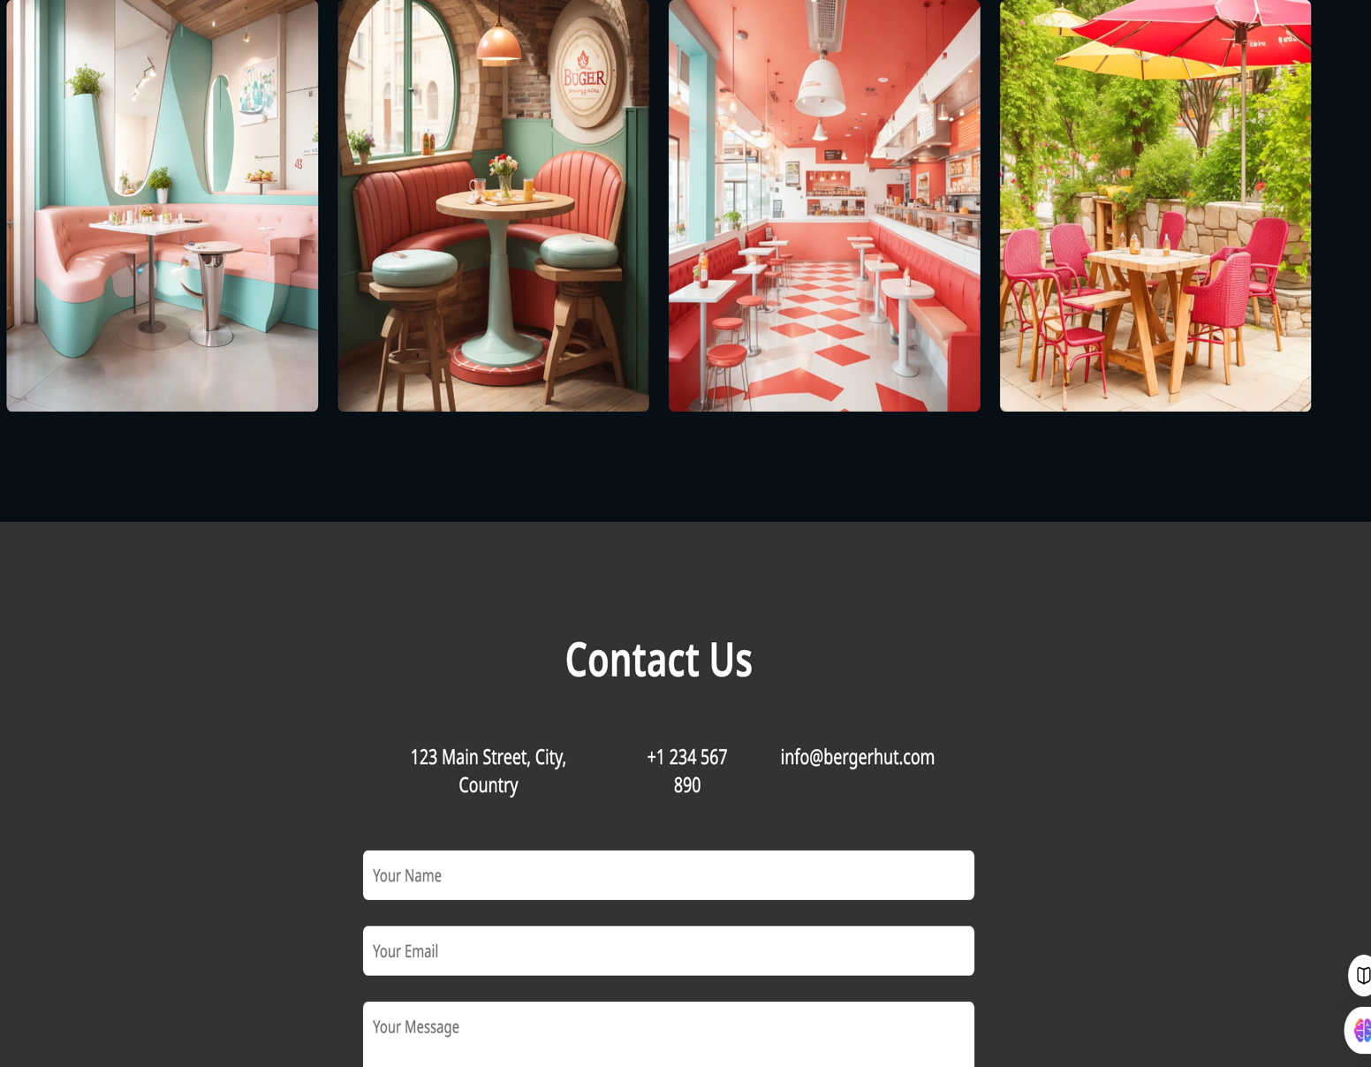

**REFERENCES**

1. W3SCHOOLS: <https://www.w3schools.com>
2. CHATGPT: [www.chatgpt.com](http://www.chatgpt.com)
3. GITHUB: <https://github.com/>